Age Group

Table as per design

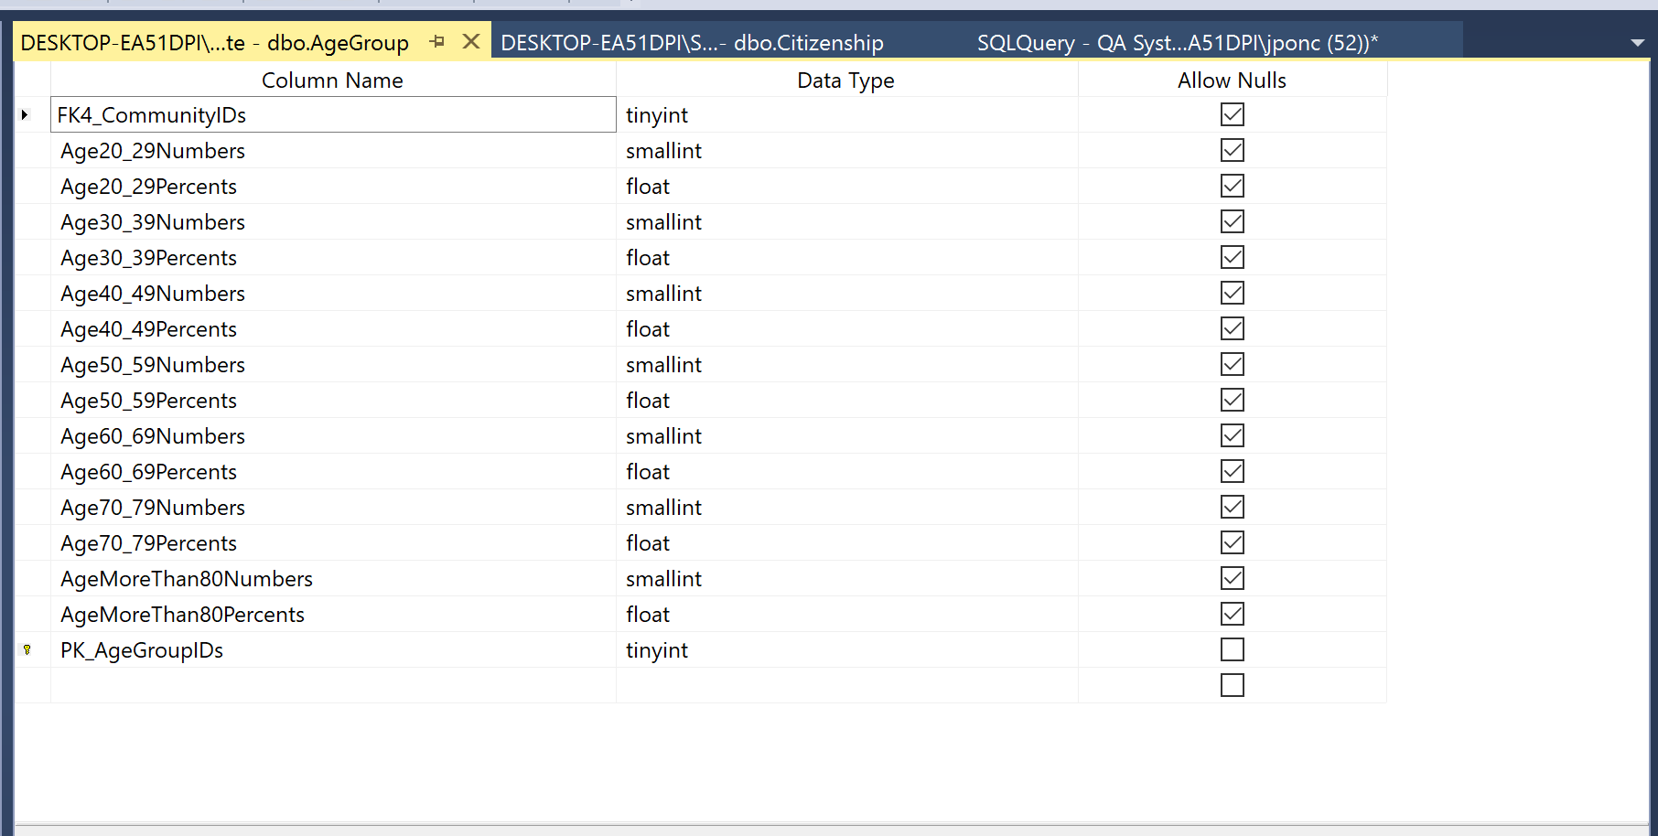

Rows retrieved 198 rows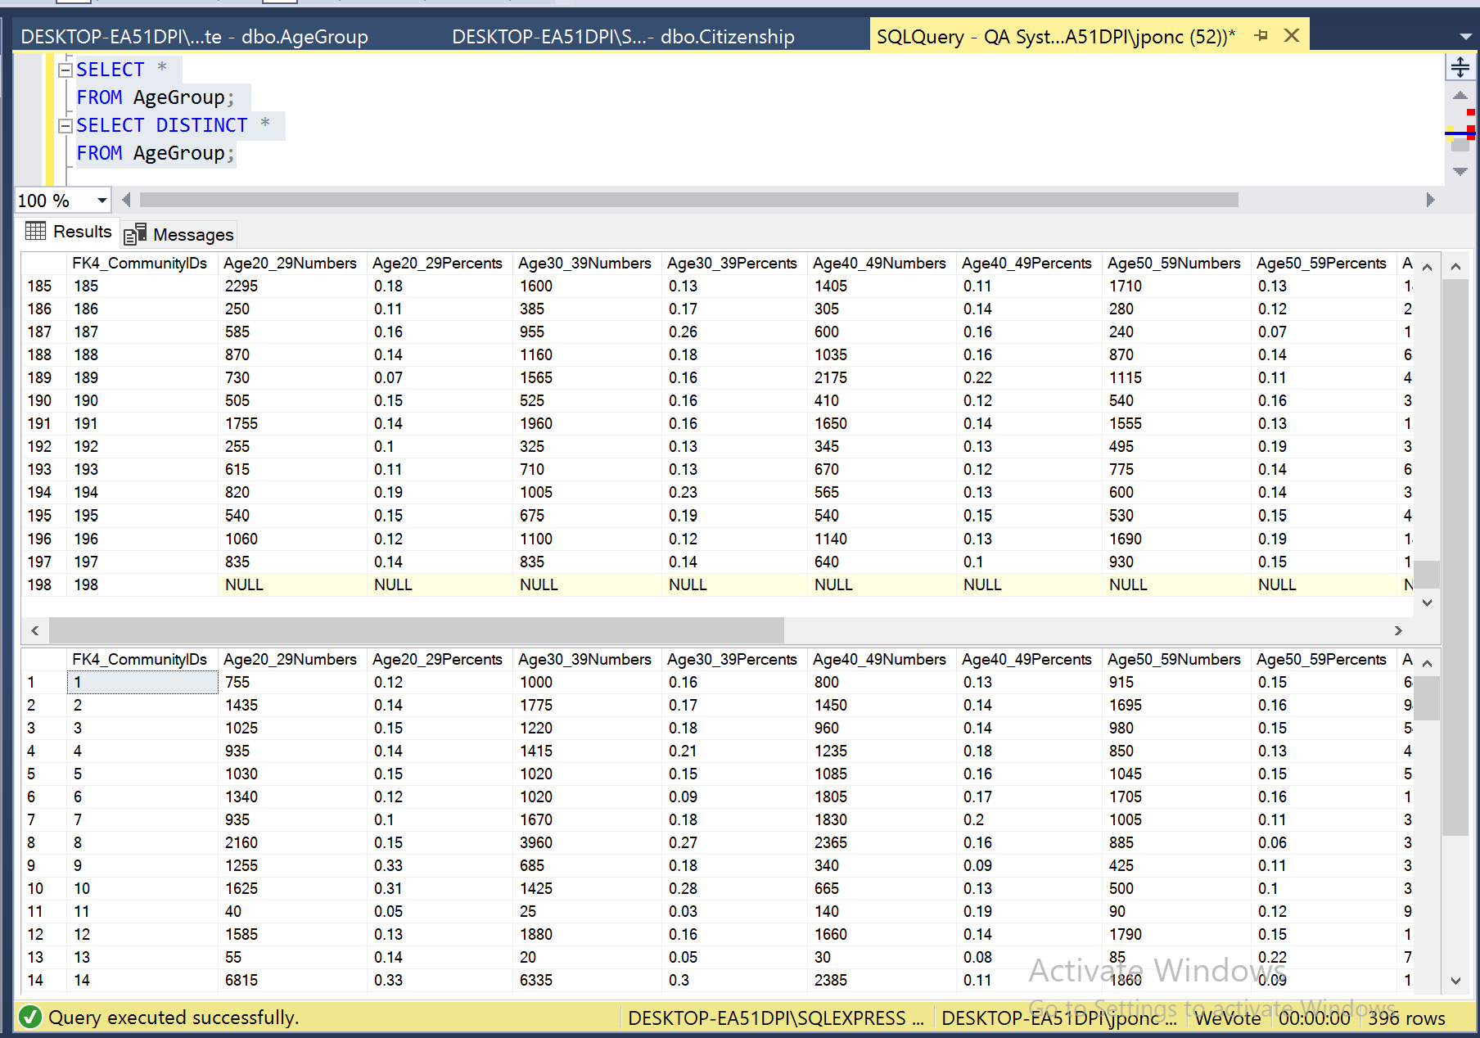

Data Manipulation

Primary Key - Explicit Insert for Identity Column

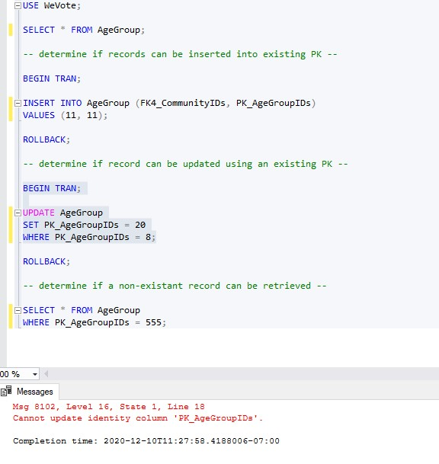

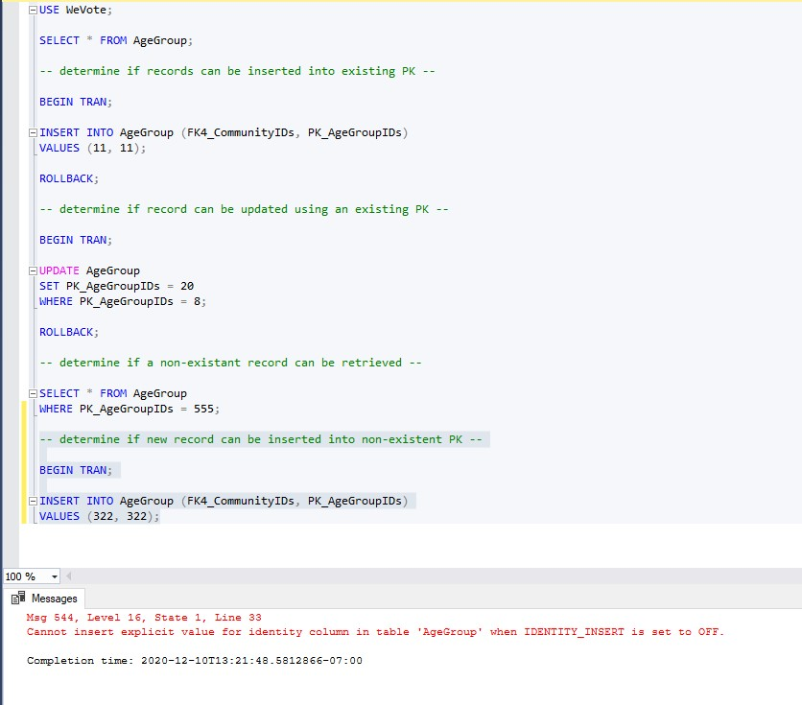

Primary Key – Update



Primary Key – query non existent ID

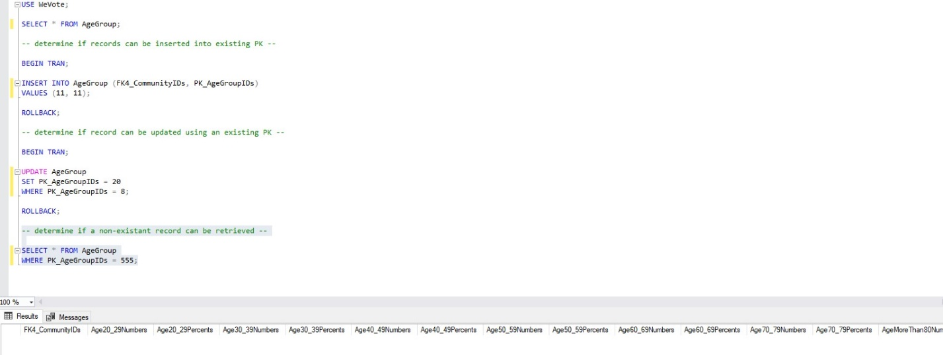

Primary Key not related to other and with Foreign Key

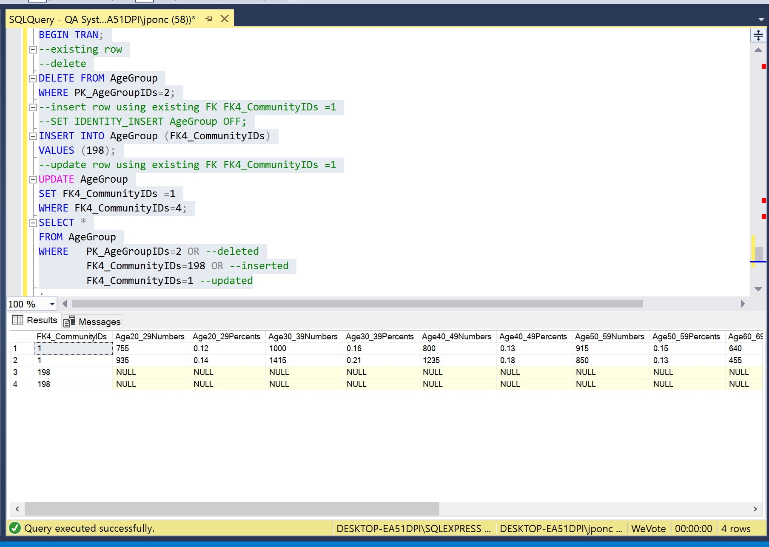

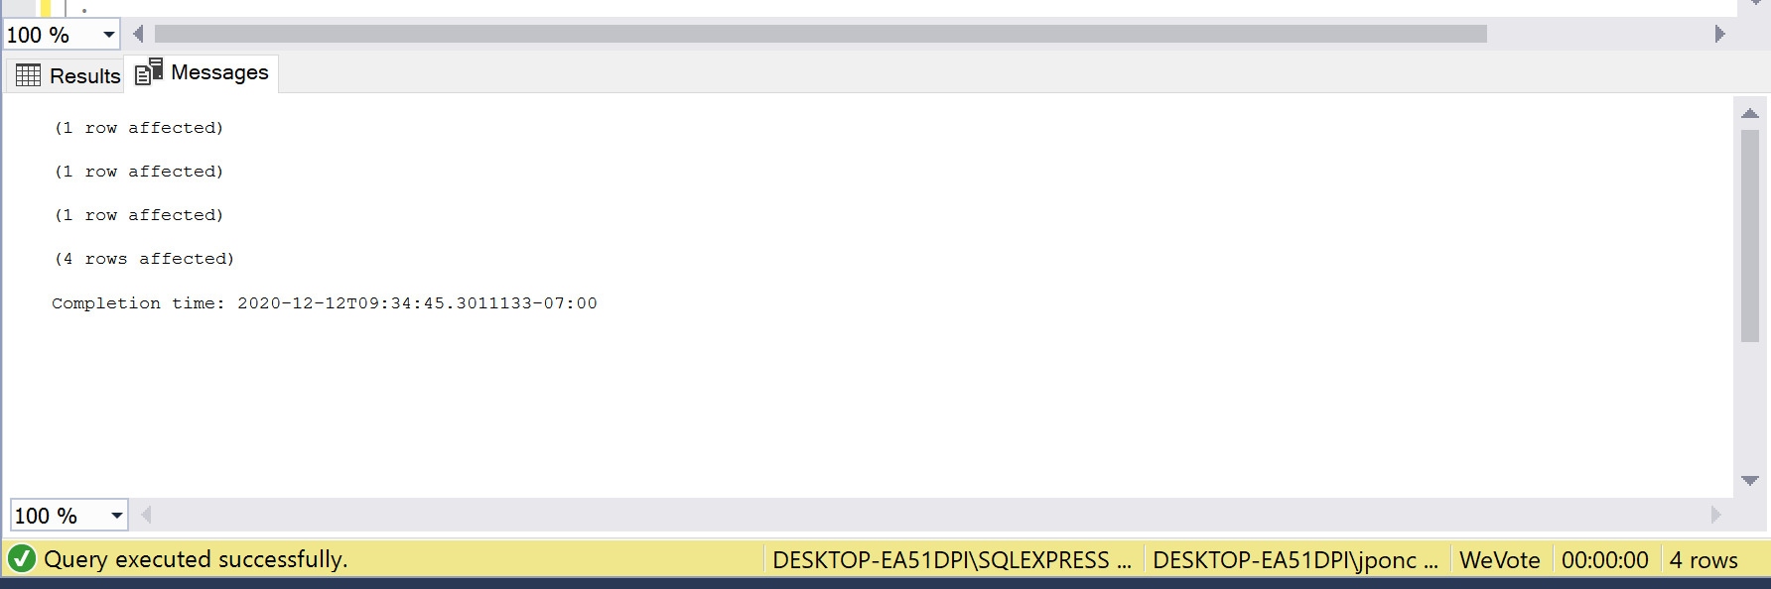

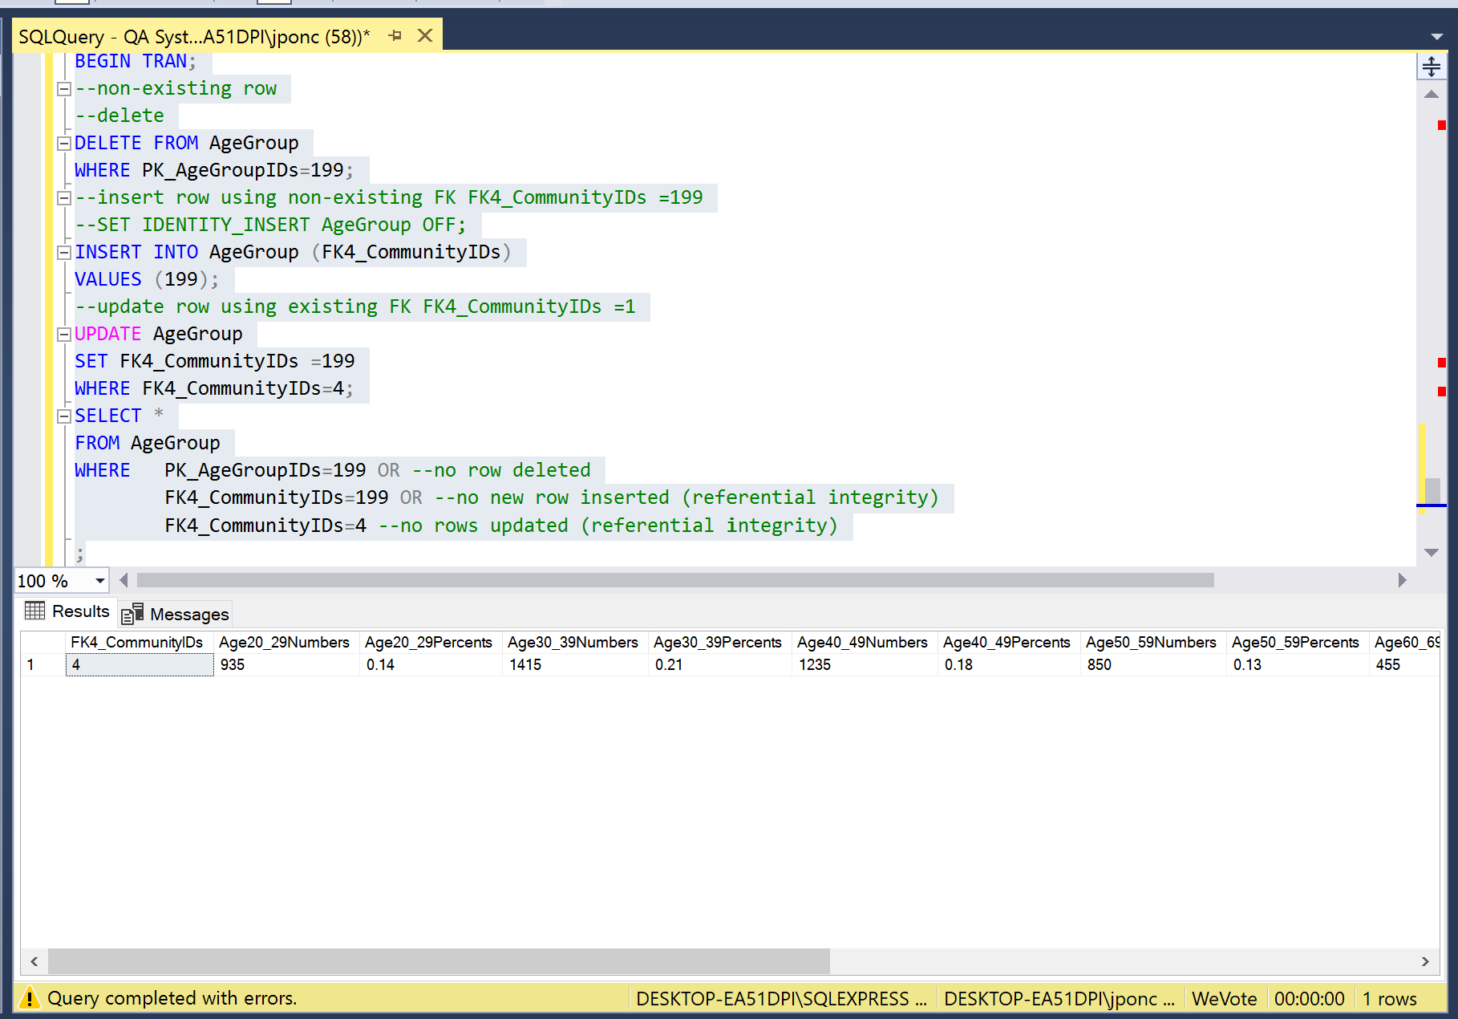

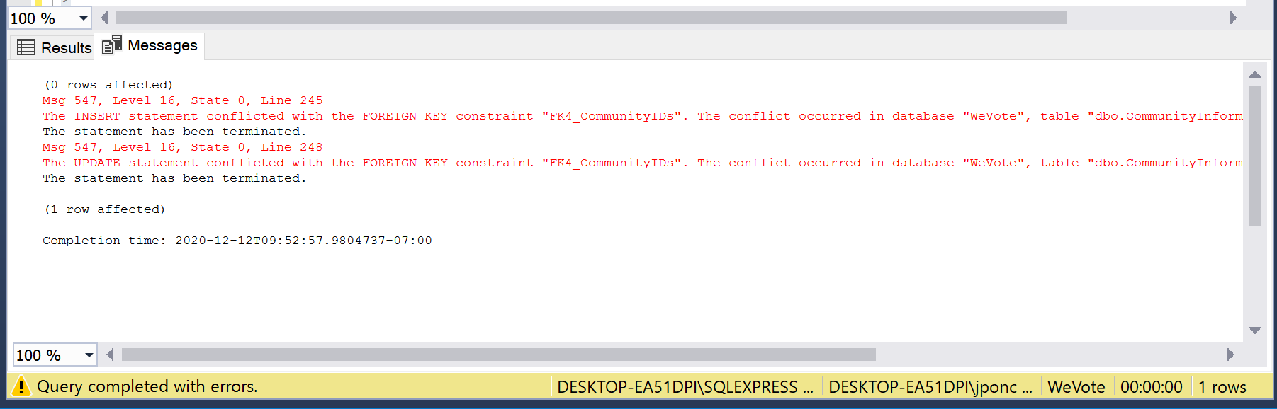

PK non null constraint:

Negative Value constraint

